# Intro to JavaScript Week 5 Coding Assignment

**Points possible:** 70

|  |  |  |
| --- | --- | --- |
| Category | Criteria | % of Grade |
| Functionality | Does the code work? | 25 |
| Organization | Is the code clean and organized? Proper use of white space, syntax, and consistency are utilized. Names and comments are concise and clear. | 25 |
| Creativity | Student solved the problems presented in the assignment using creativity and out of the box thinking. | 25 |
| Completeness | All requirements of the assignment are complete. | 25 |

**Instructions:** In VS Code, or an IDE of your choice, write the code that accomplishes the objectives listed below. Ensure that the code compiles and runs as directed. Take screenshots of the code and of the running program (make sure to get screenshots of all required functionality) and paste them in this document where instructed below. Create a new repository on GitHub for this week’s assignments and push this document, with your JavaScript project code, to the repository. Add the URL for this week’s repository to this document where instructed and submit this document to your instructor when complete.

**Coding Steps:**

1. Create a menu app as seen in this week’s video. What you create is up to you as long as it meets the following requirements.
   1. Use at least one array.
   2. Use at least two classes.
   3. Your menu should have the options to create, view, and delete elements.

**Screenshots of Code:**

class Player {

constructor(name, position) {

this.name =name;

this.position = position;

}

describe() {

return `${this.name} plays ${this.position}.`;

}

}

class Team {

constructor(name) {

this.name = name;

this.players = [];

}

//MethodAdd

addPlayer(player) {

if (player instanceof Player) {

this.players.push(player);

} else {

throw new Error(`You can only add a instance of Player, Argument is not a player: ${player}`);

}

}

describe(){

return `${this.name} has ${this.players.length} players. `;

}

}

class Menu {

constructor() {

this.teams = [];

this.selectedTeam = null;

}

start() {

let selection = this.showMainMenuOptions();

while (selection != 0) {

switch(selection) {

case '1':

this.createTeam();

break;

case '2':

this.viewTeam();

break;

case '3':

this.deleteTeam();

break;

case '4':

this.displayTeams();

break;

default:

selection = 0;

}

selection = this.showMainMenuOptions();

}

alert('Goodbye!');

}

showMainMenuOptions() {

return prompt(`

------------- JORGE RAFAEL CRUZ DE LEON ------------

0) Exit

1) Create new team

2) View team

3) Delete team

4) Display all teams

`);

}

showTeamMenuOptions(teamInfo){

return prompt(`

----SubMenu Player-----

0) Back

1) Create player

2) Delete player

------------------------------

${teamInfo}

`);

}

displayTeams() {

let teamString = '';

for (let i =0; i < this.teams.length; i++) {

teamString += i + ') ' + this.teams[i].name + '\n';

}

alert(teamString);

}

createTeam() {

let name = prompt('Enter name for new team');

this.teams.push(new Team(name));

}

viewTeam() {

let index = prompt('Enter the index of the team you wish to view:');

if (index > -1 && index < this.teams.length) {

this.selectedTeam = this.teams[index];

let description = 'Team Name: ' + this.selectedTeam.name + '\n';

for (let i = 0; i < this.selectedTeam.players.length; i++) {

description += i + ') ' + this.selectedTeam.players[i].name +

' - ' + this.selectedTeam.players[i].position + '\n';

}

let selection = this.showTeamMenuOptions(description);

switch (selection) {

case '1':

this.createPlayer();

break;

case '2':

this.deletePlayer();

}

}

}

createPlayer() {

let name = prompt('Enter name for new Player: ');

let position = prompt('Enter position for new Player: ');

this.selectedTeam.players.push(new Player(name, position));

}

deletePlayer() {

let index = prompt('Enter the index of the player you wish to delete: ');

if (index > -1 && index < this.selectedTeam.players.length) {

this.selectedTeam.players.splice(index, 1);

}

}

}

let menu = new Menu();

menu.start();

**Screenshots of Running Application:**

**Main Menu**

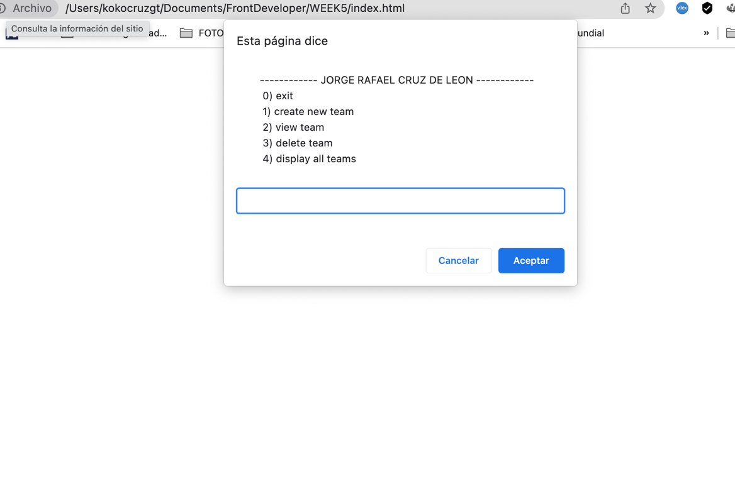

**Option 0. EXIT**

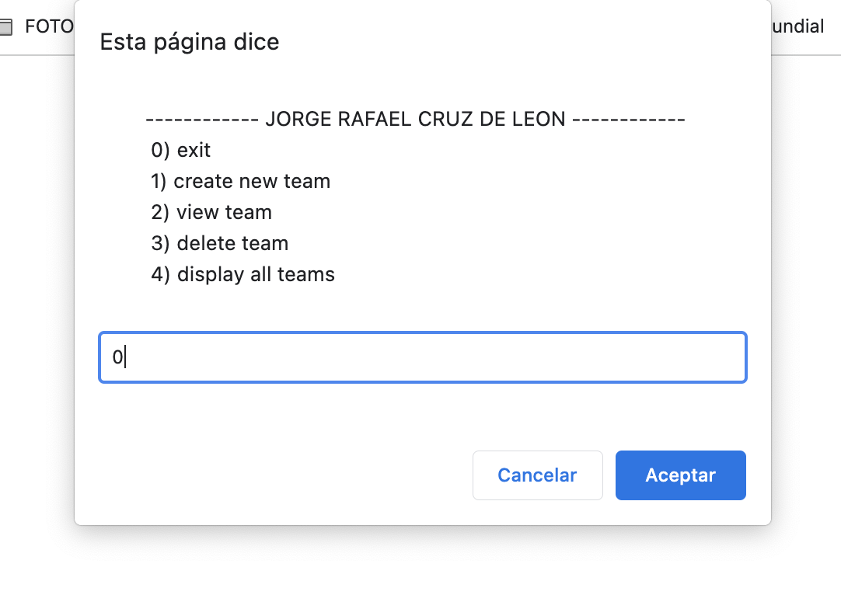

**OPTION 1. CREAE TEAM**

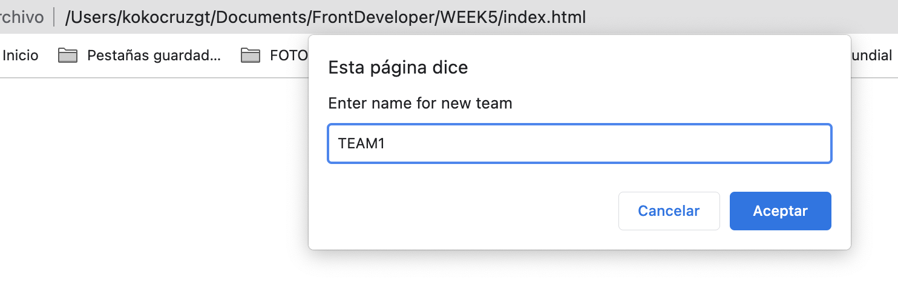

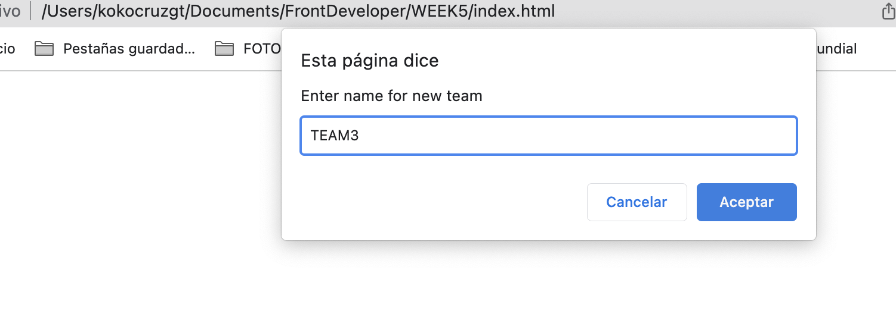

**OPTION 2. VIEW**

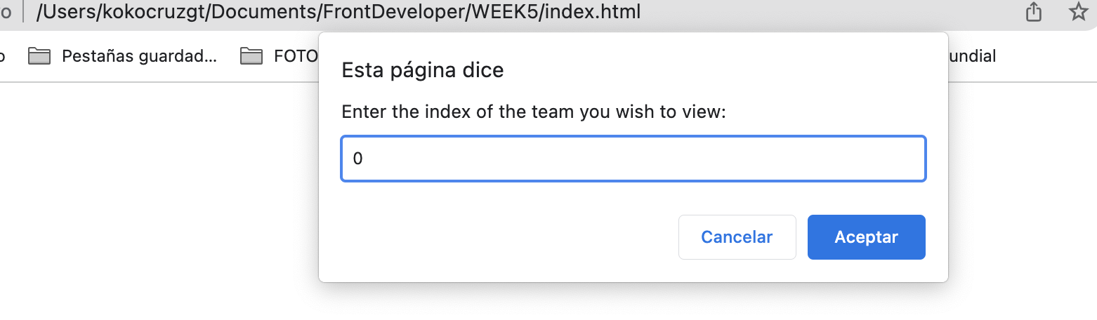

**VIEW TEAM AND SUBMENU PLAYER.**

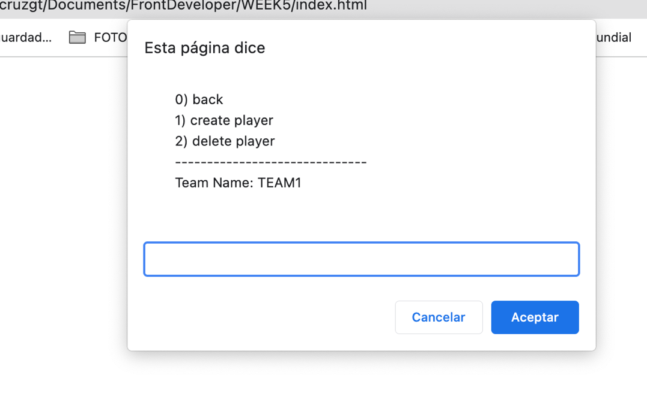

**CREATE A PLAYER**

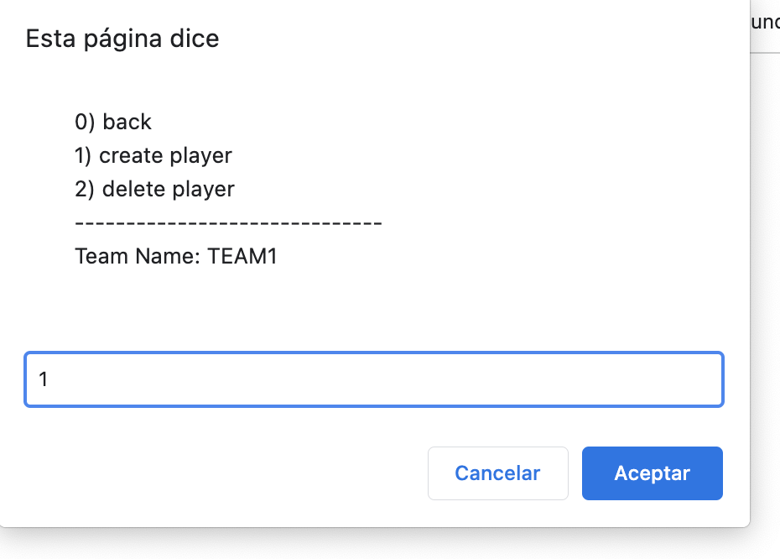

**NEW PLAYER**

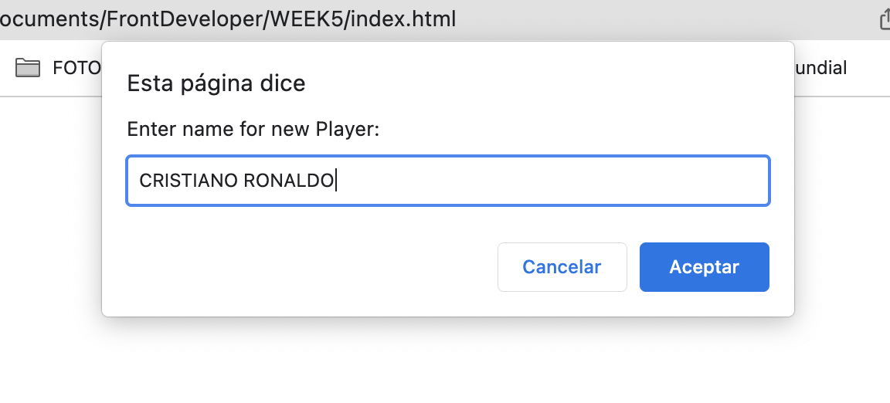

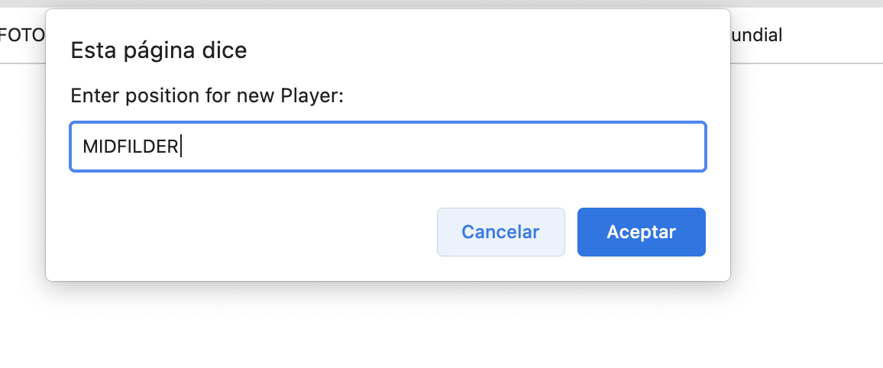

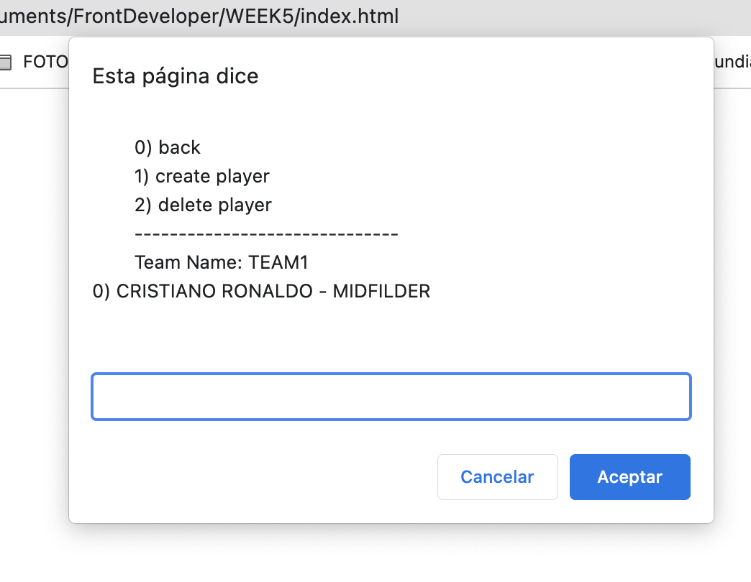

**BEFORE DELETE**

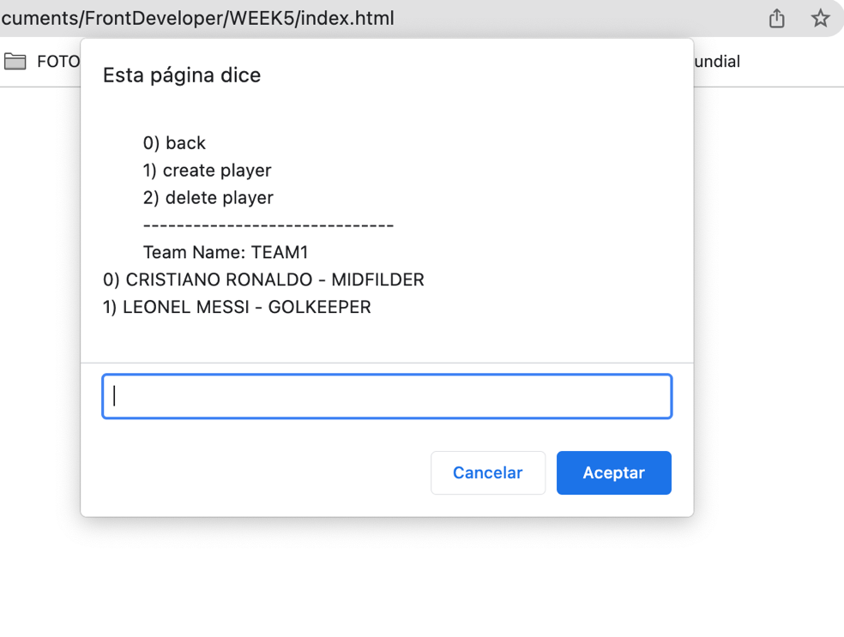

**DELETE**

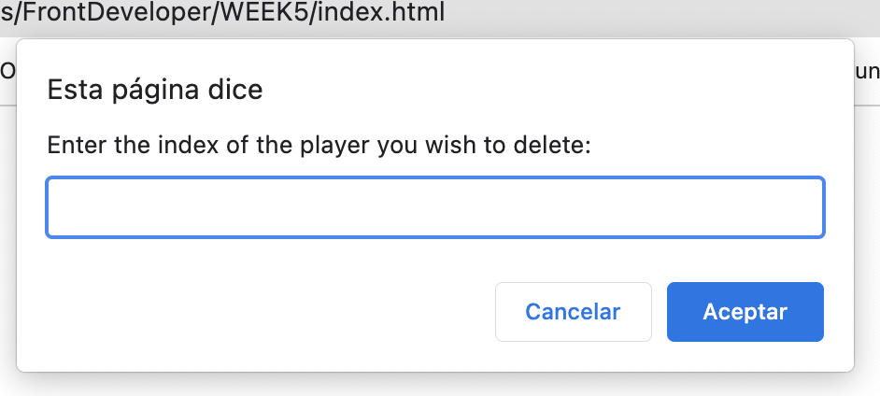

**AFTER DELETE**

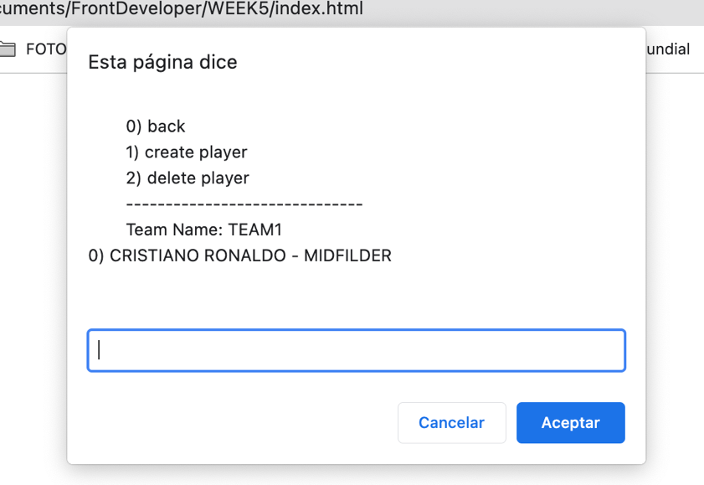

**DISPLAY ALL TEAMS**

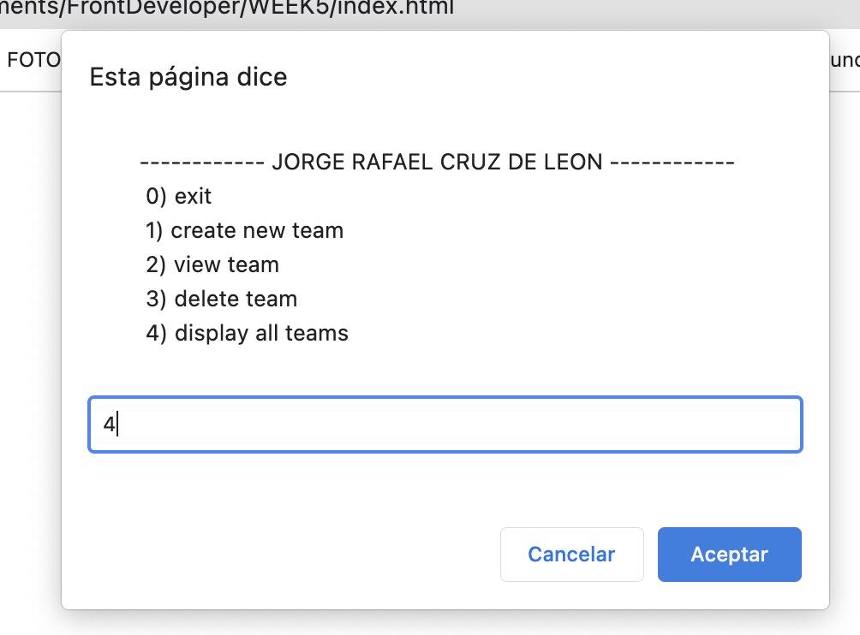

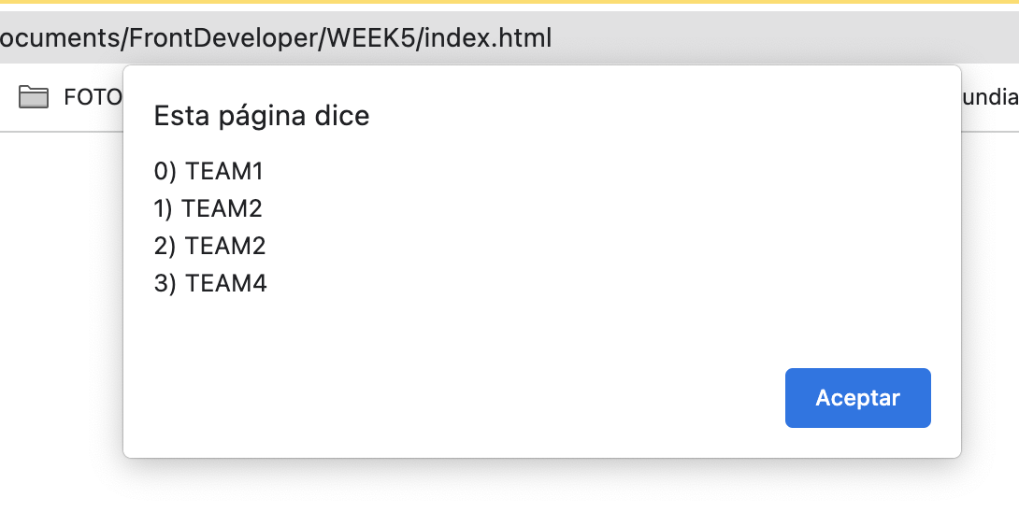

**URL to GitHub Repository:**

[**https://github.com/rafacruz78gt/week5**](https://github.com/rafacruz78gt/week5)

**SCREET SHOOT**

